
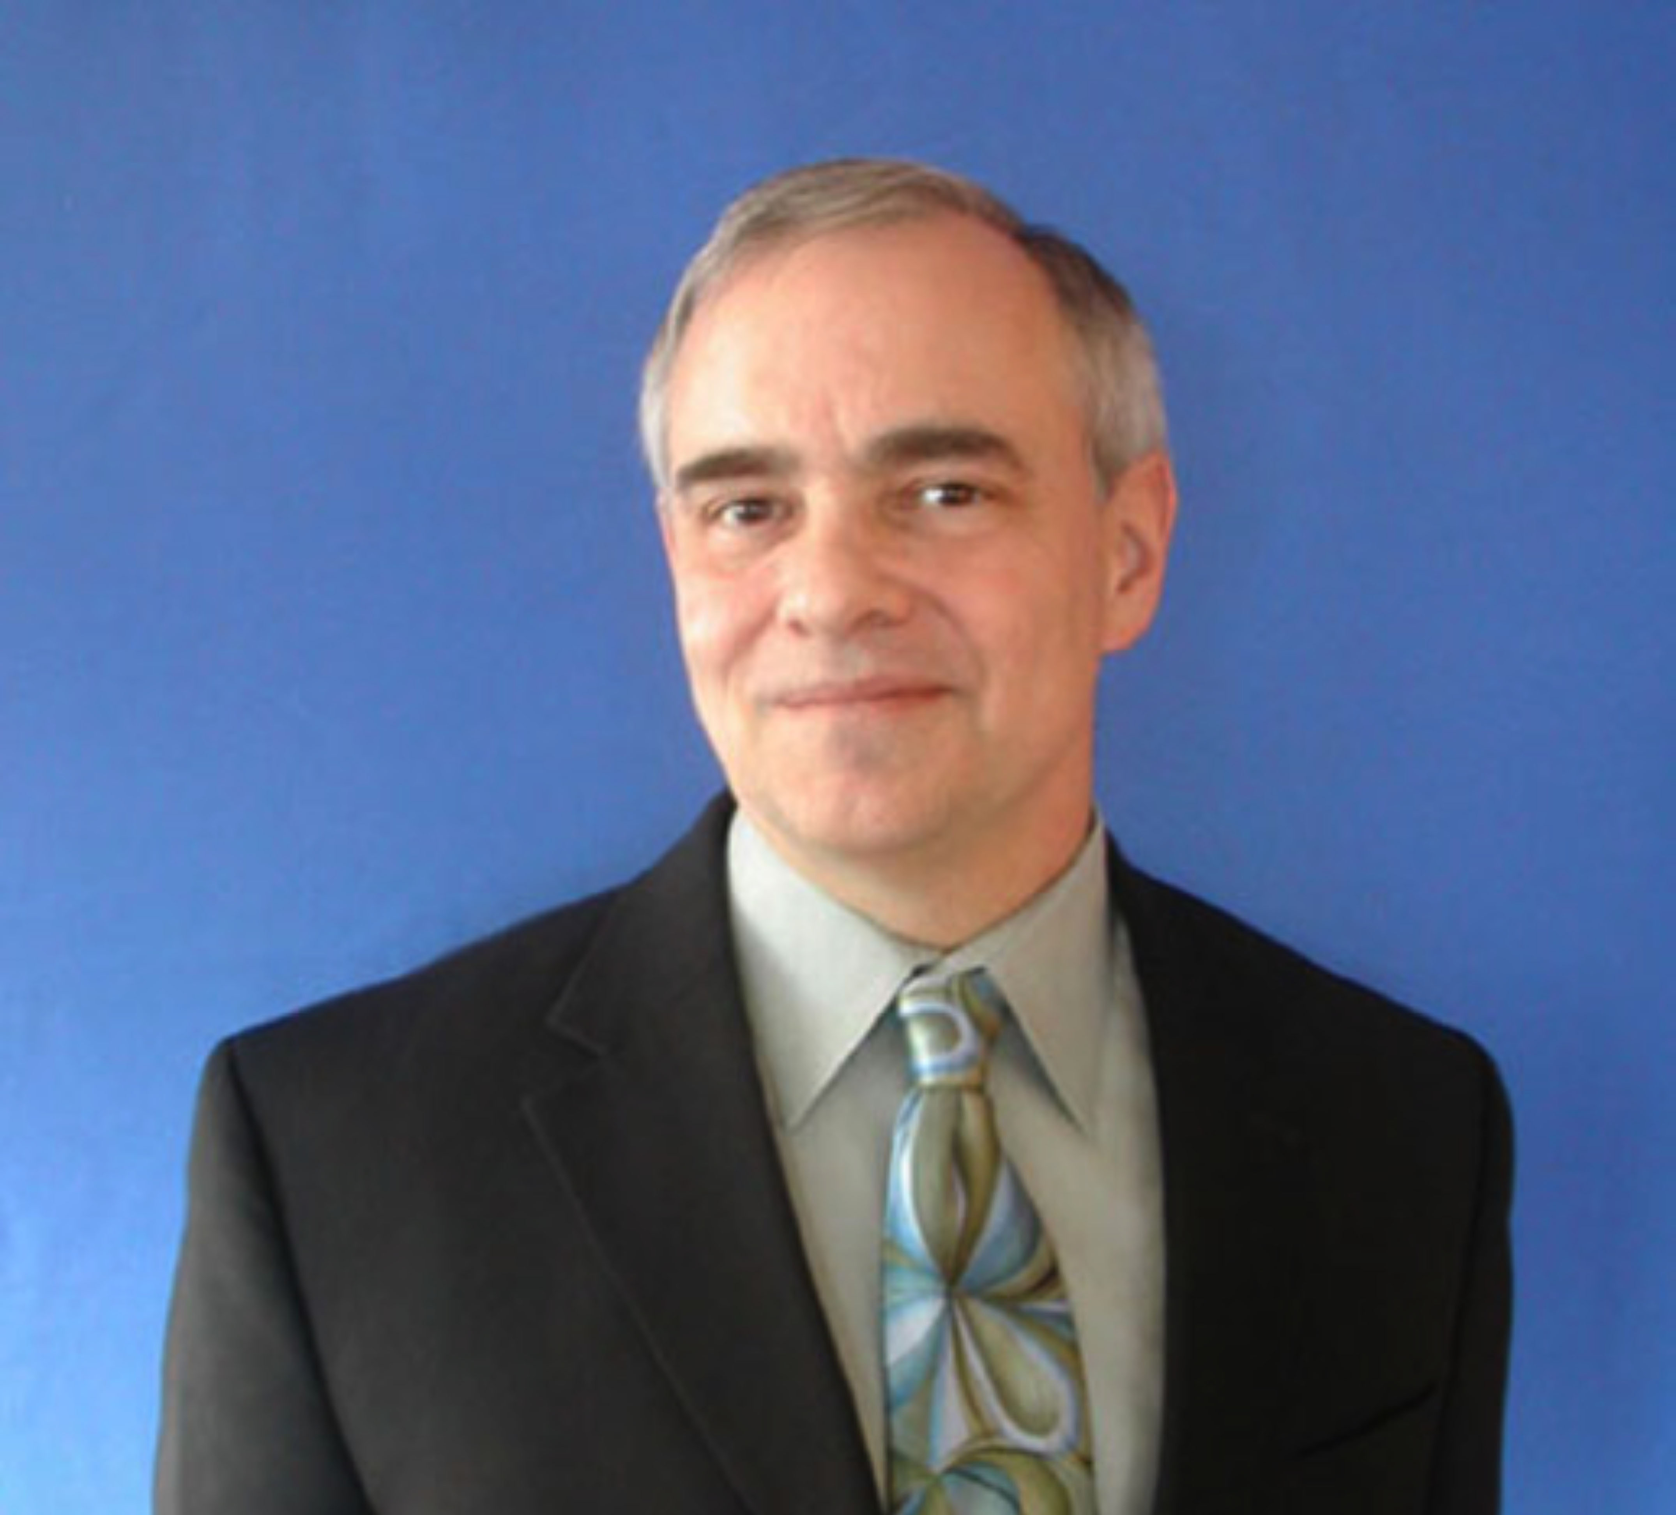
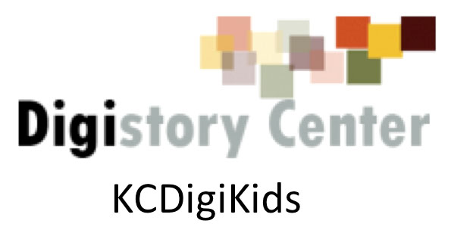

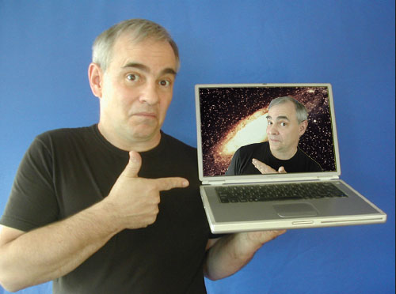
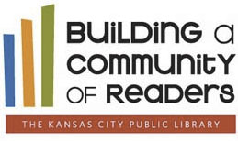
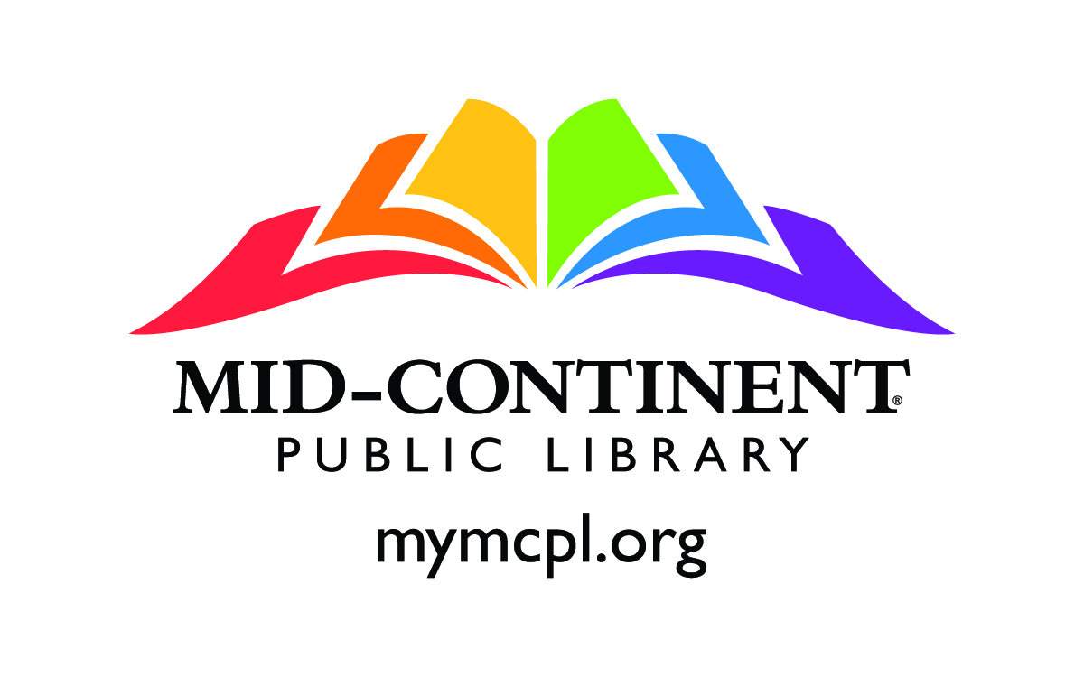

KCdigiKids is a coalition of regional non-profit and educational groups who are interested in helping K-12 youth to become effective digital storytellers. We recognize that our collective efforts allow us to achieve more opportunities for youth by sharing information, resources and expertise. KCdigiKids is a program of the Digital Storytelling Center of Kansas City (KC DigiSTORY Center). The objectives of the DigiSTORY Center are to:
- Advance the digital storytelling industry in the central Midwest and beyond
- Support current working professionals and advance their expertise in digital storytelling
- Develop our region’s next generation of digital storytellers

About KCdigiKids:
Books by Jason Ohler:
Digital Storytelling in the Classroom: New Media Pathways to Literacy, Learning and Creativity
Digital Community, Digital Citizen
  - December 9, 2013 Woodneath Library Center

New Media Narrative and Digital Storytelling—Using Digital Technology to Tell Your Story
Jason Ohler

KCdigiKids Presents:
Jason Ohler is a professor emeritus, speaker, writer, teacher, and cyber researcher. He is also a lifelong digital humanist who is well known for the passion, insight and humor he brings to his presentations, projects and writings. He has worked both online and in classrooms at home and internationally for over a quarter century helping students develop the new literacies they need to be successful in the digital age.

About Jason Ohler:

Nulla facilisi
8:30 a.m. Registration & Continental Breakfast (sponsored by Mid-Continent Public Library)
9:00 a.m. Digital Storytelling Instruction -- Presentation & Discussion
Topics include a number of the practical aspects related to helping students create thoughtful, effective media, particularly digital stories; learning how to evaluate "story" as well as how to use stories in content areas; how to listen to, deconstruct and evaluate new media narrative and digital stories so you can give students helpful feedback on their media projects; learn how to use "media grammar" as a way to talk to your students about the media they produce.
12:00 a.m. Lunch (provided by Mosaic Life Care)
- Lunch areas throughout Woodneath Library Center
- OR bring lunch to Community Hall for KCDigiKids Update
1:00 p.m. Story Planning Session for Participants
3:00 p.m. Story Production Session for Participants
4:30 p.m. Regroup for Closing Remarks
5:00 p.m. Dismissal

Our imagination always outpaces our technology. The gap between the two is the distance the creative spark must jump in order to ignite our forward momentum.

Workshop Schedule:

Thank You to Our Sponsors!

Program

