OBMakerFaireKCStar

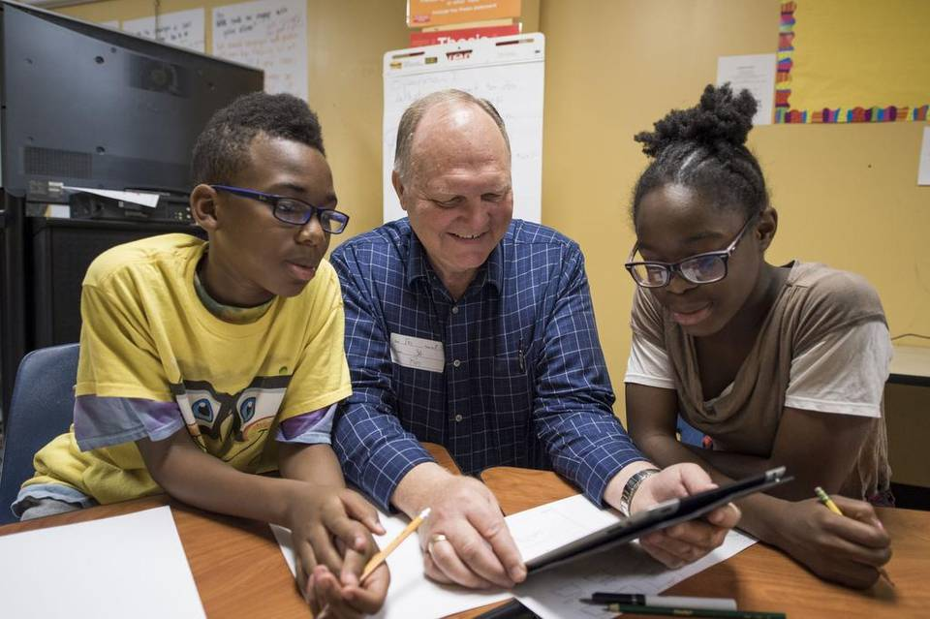

Kansas City Maker Faire Makes Its Mark with Inventors, Fans
http://www.kansascity.com/news/local/article25362742.html

