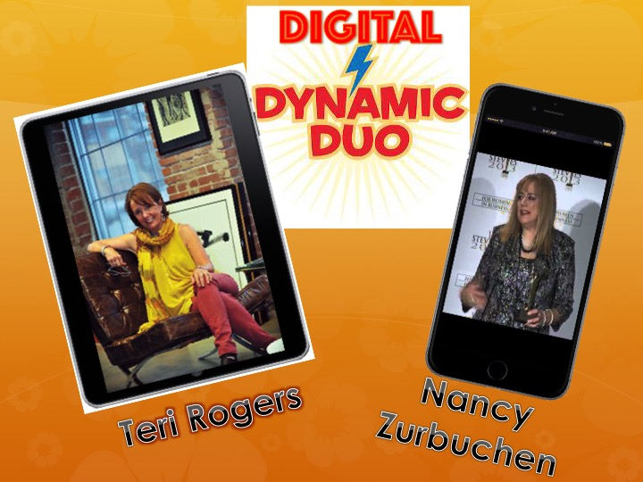
KCdigiKids Presents:
Dialogue with Two Innovative Women Leaders in KC Digital Media

Want to see more girls pursue careers in STEM? Are you encouraging girls in your programs to pursue digital media as a STEAM option? Hear how these two KC women have accomplished great things in media and have become leaders of prestigious Missouri firms.

Teri Rogers, President & CEO of Hint Studios, and Nancy Zurbuchen, President of Motional Media, are pioneers who recognized the potential for digital media business growth early on and showed KC what innovative women with leadership skills can accomplish in this STEAM-related industry. Teri and Nancy will share their experiences in a casual presentation/discussion format. Audience interaction and questions are encouraged. Enjoy this session from within the fabulous Hint Studios located in KC’s Creative Crossroads district.


Thursday, September 24, 2015, 5:30 – 7:00 p.m.
Hint Studios, 1906 Wyandotte Street, Kansas City, MO

NOTE: This event is a closed event intended solely for members of the KCdigiKids Coalition—leaders of non-profits, libraries and K-12 education who are interested in providing digital storytelling training to their constituents. (This program is not intended for kids).

This is offered as part of the KCdigiKids program of the KCdigiSTORY Center.

